Short Term Exchange: Culture and Sports CAMP – Culture, Tourism and Sports
Brazil - District: D4730 - Curitiba
Motto: Culture, Tourism and Sports
Age: From 14 to 18 years old
Attendees: 10 exchange students, 2 from each country. Criteria will be the arrival of the application. The two first from each country will be registered.
Lenght: 3 weeks
Date: July 17th to August 6th 2016
Arrival: July 17th 2016
Return: August 6th 2016
Arrival at CWB Airport (Afonso Pena Aiport – City of Curitiba)
Lodging: Host families and lodging places
Program The participants will be hosted in Brazilian families to get to know the Brazilian way of living.
During their stay they will visit the city, museums, monumental parks.
They will be able to have sports activities as play soccer, swimming and capoeira, walking an mountain.
Touristic places to visit in Curitiba, the near beach area and country side nearby.
Please inform the preferable sports to practice: Soccer, swimming, tennis, basket ball
Organization: 4730 District and Rotary Clubs
About the City: https://en.wikipedia.org/wiki/Curitiba
Rules:
- Attend 1 Rotary Meeting;
- 2 students by country;
- Submit the Application Form for the Short Term Exchange Program no later than May 30th
- International Health Insurance for Travelers must be acquired before leaving the home country;
- The student will be always accompanied by a rotarian.
Participation Fee: USD 350. Must be paid in the arrival to the hosting Chairperson
Application Form must be submitted to:
Chairperson Valdineia Spricio
Email: valdineia.de@terra.com.br
Roseanne Fontana
Email: roseanne.s.fontana@hotmail.com
Copying Anaides Orth
Email: anaidesdistrito4730@gmail.com
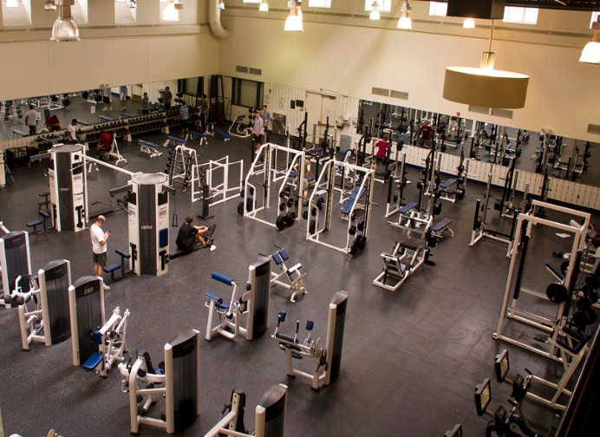
Be welcome to Brazil D 4730!
