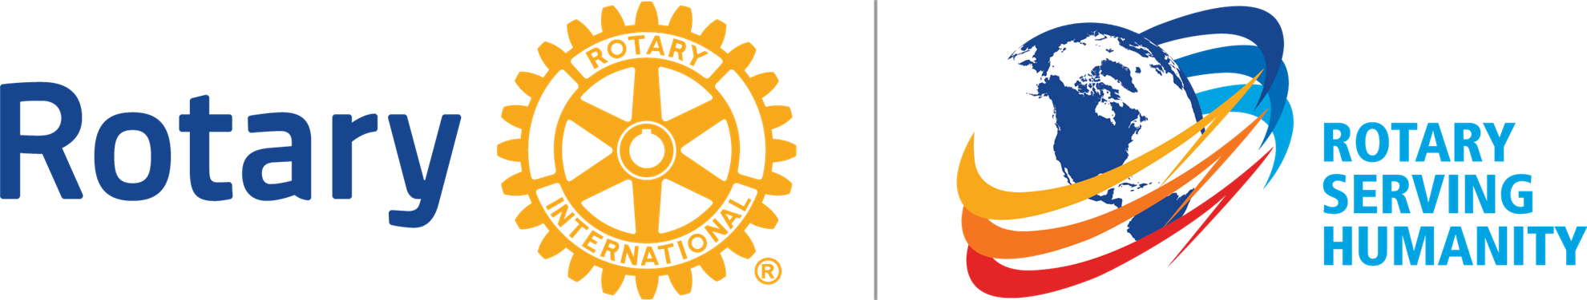
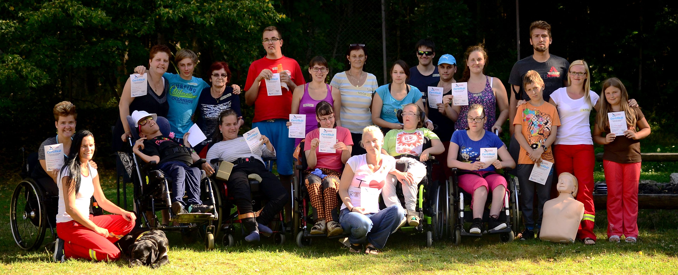

HandiCamp 2017
Providing disabled youngsters with meaningful time
When: 17/7/2017 - 30/7/ 2017

Where: Březejc u Velkého Meziříčí, Czech Republic
https://goo.gl/maps/HCf7LGBBKCK2
The resort was constructed for wheelchair users. It is completely barrier free and features a swimming pool, a rehabilitation centre and a gym.

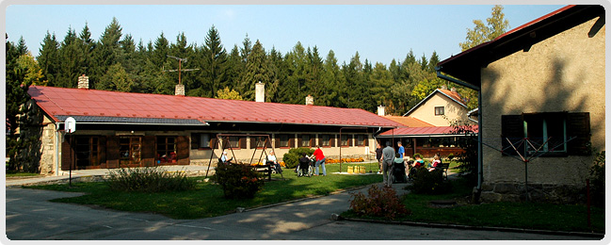

Who: 10 physically disabled teenagers
10 assistants
the organization team

All participants are supposed to be able to communicate in English.

Program: sport activities, interactive social activities, art therapies, workshops, forest walks and trips

Fee: 2000 CZK (75 EUR)

Additional information:
Please let us know about your arrival as soon as possible. Health and accident insurance and third party liability risk are required. Participants will finance their travel expenses themselves. We kindly ask you to inform us about your food habits and needs (vegetarians, allergies) in advance. The food provided is based on Czech cuisine.
Participants are required to bring their personal assistants.
For other questions or queries, do not hesitate to contact the camp leader Jiří Kadlec: kadlec.jiri@mail.com
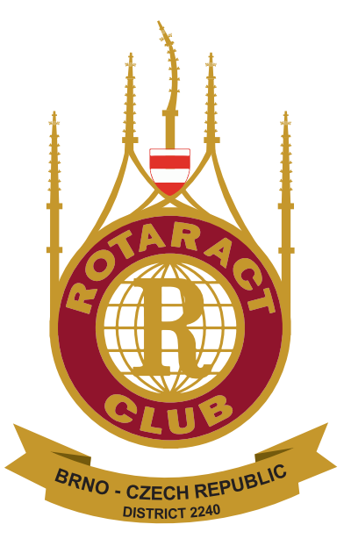

Handicamp 2017 is organized by
Rotaract Club Brno in cooperation with Rotary Club Brno.

