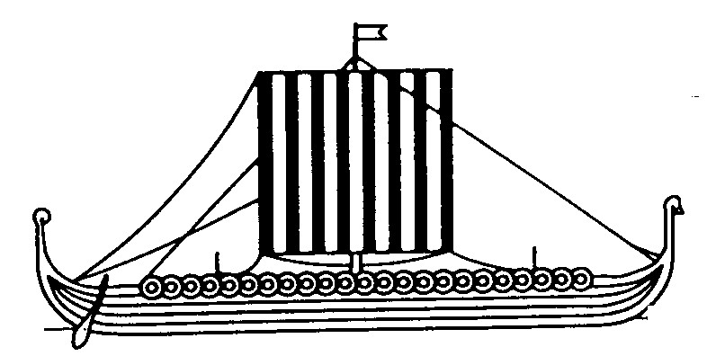

Invitation to our Biking Camp Frederikssund 2018 in Denmark

It is a great pleasure for Frederikssund Rotary Club to invite 16 young people (age 18-22) to join our camp from August the 12th to August the 26th.
The Camp will take place in Frederikssund and its surroundings with visits to sights in Copenhagen and Roskilde.
Frederikssund is a fairly small town with 25.000 inhabitants, 45 km north-west of Copenhagen. It is beautifully situated on the shore of Roskilde Fjord, which was one of the significant waterways of the Vikings.

During your stay, you will be hosted mainly with Rotarian Families who all speaks English.
It is important too that you speak English at the minimum on conversation level.
You will be looking forward to many social activities and various sightseeing in Frederikssund and the surrounding area, where the transportation mainly will be on bikes.
It is therefore vital, that you are familiar with biking.
The host families will provide you with bikes. If you have a biking helmet please bring it!
The Camp will be completely free of charge for you, but you must pay your transport to and from Frederikssund, and you must bring some pocket money.

We are still working with the program in details, but here are some hints to show you, what you might experience:
Visit to the Town Hall, where the Mayor will brief you on our Constitutional System
Visit to Frederikssund Gymnasium where the Headmaster gives an orientation about the Danish educational system.
Visit to the Viking Settlement in Frederikssund
Guided tour at Jægerspris Castle
Biking in the Forest
A sporting day with tennis, golf, canoeing, walking and running
Sailing on the Fjord
Sightseeing in Roskilde with the Cathedral and the Viking Boat Museum
Sightseeing in Copenhagen
Visit to the Carlsberg Brewery
..and hours/days on the beaches nearby.. depending on the weather…
Farewell party in the Viking Village

For more information on Frederikssund please visit: www.visitfrederikssund.dk

When you have decided to join our Camp, we will pass on some more relevant information to you i.e. what to pack, some arrival procedures etc.

Submit completed application:
https://www.rotary.dk/sites/default/files/inline-files/Short%20Term%20Application%20Form%202015_1_0.pdf

and send it to: cm-st@rotary-yep.net

We are looking forward to welcoming you in August!

Kind regards
Frederikssund Rotary Club
Short Term Group (esben.brandstrup@gmail.com cell+45 2246 3511)

