 | ROTARY INTERNATIONAL  YOUTH EXCHANGE PROGRAM | 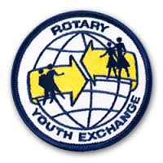
Invitation to International Winter Camp

from 26/12/2016 to 08/01/2017

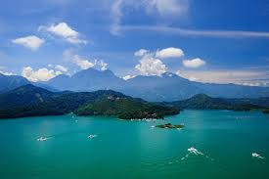

Camp Name: “Discover Sun Moon Lake – the Heart of Taiwan”

Host District: D3460 of Rotary Youth Exchange Multidistrict Taiwan (RYEMT)

Organizing RC: RC Sun Moon Lake

Participants: max. 12 youths aged 16-18 years old, one boy or one girl from each country on the basis of first come first served. Participants will receive acceptance information as soon as possible.

Camp Focus: friendship, cultures, sightseeing, sports and fun

Camp Language: English (with some Mandarin Chinese)

Costs: Only round trip tickets to Taiwan and pocket money for personal expenses

Accommodation: study center dormitory, host families & youth hostels

Clothing: casual wear for activities like sightseeing, hiking, swimming and sports

Insurance: All participants must be insured against illness, accident and third party damages according to RI recommendation.

Arrival: December 26th, 2016- Taipei Taoyuan International Airport (TPE)

Departure: January 08th, 2017- Taipei Taoyuan International Airport (TPE)

Applications: Send EEMA application in PDF format (with color photo and sponsor club/district signatures) to campsd3460@gmail.com

ATTN: Doris Huang, STEP Coordinator of RYEMT, Cell: +886 937 755905
Camp Program:

Dec. 26, 2016 (Mon.) Arrival in Taiwan, accommodation in study center
Dec. 27, 2016 (Tues.) Orientation and cruise tour in Sun Moon Lake and surrounding areas
Dec. 28, 2016 (Wed.) Outdoor and water sports with local teenagers
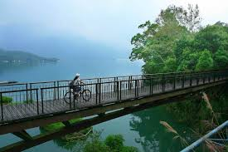
Dec. 29, 2016 (Thurs.) Local industries and black tea cultural visits
Dec. 30, 2016 (Fri.) Host families stay
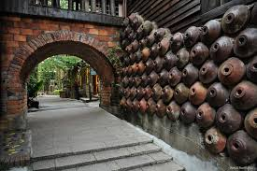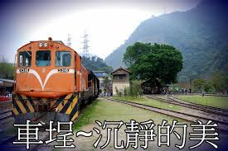
Dec. 31, 2016 (Sat.) Taipei Tour with local students
Jan. 01, 2017 (Sun.) Taipei Tour with local students
Jan. 02, 2017 (Mon.) Taipei Tour with local students
Jan. 03, 2017 (Tues.) Visit to Ming-Tang water power plant and pottery snake kiln
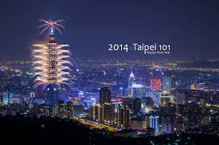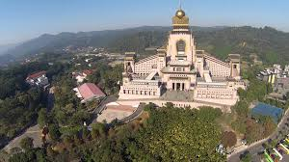
Jan. 04, 2017 (Wed.) Chung-Tai Monastery, Feeling 18-Degree Chocolate, Taiwan Central-Point Monument
Jan. 05, 2017 (Thurs.) Visits to aboriginal tribes, cultures and foods
Jan. 06, 2017 (Fri.) Formosan Cultural Amusement Park
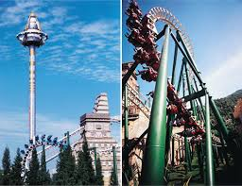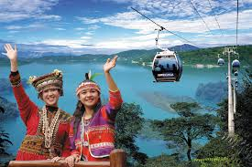
Jan. 07, 2017 (Sat.) Review seminars and farewell party
Jan. 08, 2017 (Sun.) Departure
(The above itinerary is subject to minor changes according to practical needs.)

