INTERNATIONAL YOUTH CAMP
Scotland - A Journey of Disovery
Understand our nation’s rich history and culture; learn personal skills with individual and team challenges; and make new friends

20-29 July 2017

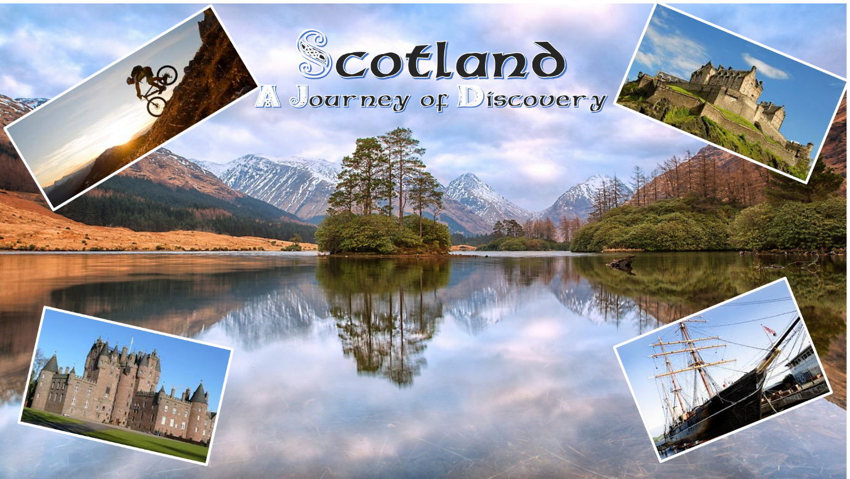

SPONSORS Scotland District 1010
PARTICIPANTS 12 – 6 male 6 female from different countries
HOSTING/ACCOMODATION You will stay for3 days with hosts and buddies (Scottish word for young person your own age) and then go to an Event Centre (dormitory accommodation) for 5 nights
AGE 16 and 17 at time of camp
PARTICIPATION FEE £150 to be paid in advance
COURSE LANGUAGE English
MEETING POINT Edinburgh Airport or Edinburgh Waverly station
APPLICATIONS email sheenarotary@gmail.com to register your interest.

OUR PROGRAMME
Thursday, 20th July
Met at Edinburgh ( airport or Waverley Station) by hosts and buddies. Evening – settling in.
Friday 21st July
Day visit to Edinburgh, Scotland’s capital, with a chance to visit the iconic Scottish Parliament, walk the historic Royal Mile and visit Edinburgh Castle.
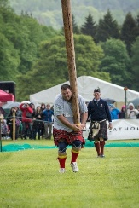
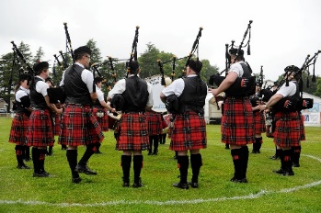
Saturday 22nd July
Explore Scottish culture with a visit to the Highland Games – dancing, sports and pipe bands.

Sunday 23rd July
Day organised by host family.
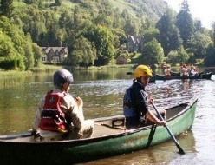
Monday 24th – Wednesday 26th July
Transfer to Belmont Outdoor Centre and enjoy a series of outdoor activities in the beautiful Perthshire countryside. For details of the activities see http://www.soec.org.uk/our-centres/belmont
Thursday 27th July
Travel to Dundee, Scotland’s fourth largest city,, with a visit to Discovery Point and the Science Museum. There will also be a chance for shopping.

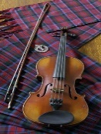
Friday 28th July
After a morning of activities at the Belmont Outdoor Centre there will be the opportunity to visit another local attraction. An evening of Scottish music and dance has been arranged for the final evening.
Saturday 29th July
Farewell to Belmont and transport to the airport / train statio

ADDITIONAL INFORMATION

If you are successful with your application we will email you with full details of
- Clothing
- Insurance
- Meeting and departure arrangements
- Dietary requirements

